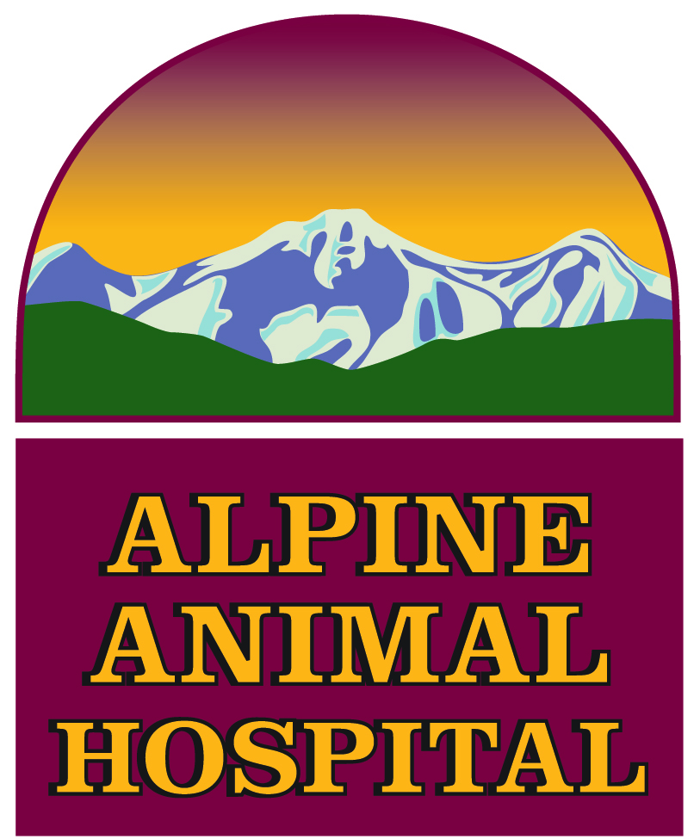
17776 Highway 82
Carbondale, CO 81623
Phone: 970-963-2371 Fax: 970-963-2372
Providing complete medical and surgical care for your animals needs since 1970

www.alpinehospital.com

AAH Intern General Duties

Assist technicians and DVMs with in-house treatments (TPR’s, bandage changes, medication administration)

Night check and treatments when ICU patients are admitted to the hospital

Back-up and eventual on-call DVM as assigned (up to 3 week nights per week) in addition to weekend and Holiday rotation

Prep surgical patients as assigned (PE, blood draws and catheters)

Serve as assistant surgeon or anesthetist

Stay or return to clinic as needed for patient in-house care

Serve as overall observer of all in-house patient records to check for errors, treatments not signed off, orders written for the next day. Correct problems that arise with proper staff memeber

Play a role in client communications with hospitalized patients and call back lists

Lab work as assigned and on days that a technician is not present

Assist with the daily restock of vehicles and hospital treatment areas worked that day, as needed

Perform independent DVM work as assigned and agreed upon by other DVMs

Assist in planning annual in-house and external seminars

Write at least one monthly article for the hospital newsletter

